Project Design Phase-II
Data Flow Diagram & User Stories

Date | 17 February 2026
Team ID | LTVIP2026TMIDS78778
Project Name | Gemini Historical Artifact Description
Maximum Marks | 4 Marks
Data Flow Diagrams:
A Data Flow Diagram (DFD) is a traditional visual representation of the information flows within a system. A neat and clear DFD can depict the right amount of the system requirement graphically. It shows how data enters and leaves the system, what changes the information, and where data is stored.
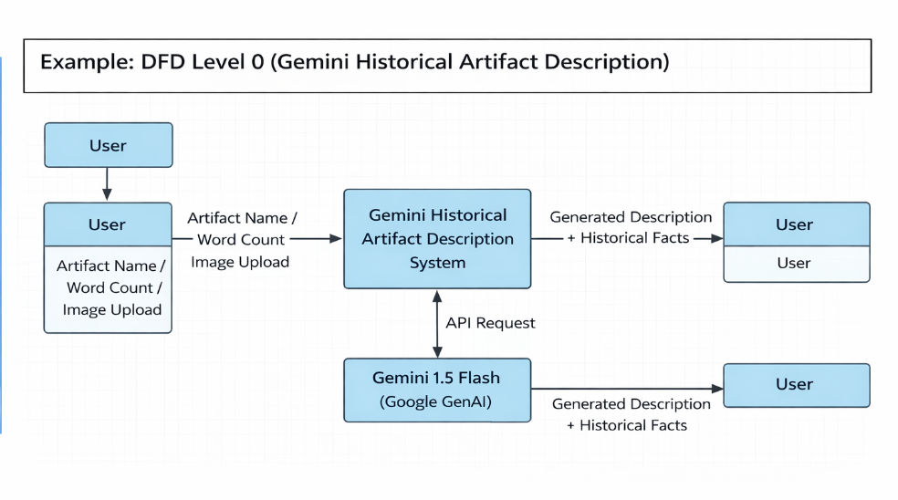

User Stories Table
User Type | Functional Requirement (Epic) | User Story Number | User Story / Task | Acceptance Criteria | Priority | Release
Customer (Mobile User) | Registration | USN-1 | As a user, I can register for the application by entering my email, password, and confirming my password. | User can successfully create an account and access the dashboard. | High | Sprint-1
Customer (Mobile User) | Registration | USN-2 | As a user, I will receive a confirmation email once I have registered for the application. | User receives confirmation email and can verify account by clicking the link. | High | Sprint-1
Customer (Mobile User) | Registration | USN-3 | As a user, I can register for the application through Facebook. | User can register and access dashboard using Facebook login. | Low | Sprint-2
Customer (Mobile User) | Registration | USN-4 | As a user, I can register for the application through Gmail. | User can register and access dashboard using Gmail login. | Medium | Sprint-1
Customer (Mobile User) | Login | USN-5 | As a user, I can log into the application by entering email and password. | User can log in successfully and access dashboard. | High | Sprint-1
Customer (Mobile User) | Dashboard | USN-6 | As a user, I can view my profile and account details on the dashboard. | User can see and update profile information. | High | Sprint-1
Customer (Mobile User) | Dashboard | USN-7 | As a user, I can view activity history on my dashboard. | User can see previous activities and transactions. | Medium | Sprint-2
Customer (Web User) | Registration | USN-8 | As a web user, I can register using email and password. | Web user account is created successfully and dashboard is accessible. | High | Sprint-1
Customer (Web User) | Login | USN-9 | As a web user, I can log in using my credentials. | Web user can access system after successful login. | High | Sprint-1
Customer (Web User) | Dashboard | USN-10 | As a web user, I can access the dashboard to view services and details. | Dashboard loads correctly with user information. | High | Sprint-1
Customer Care Executive | Customer Support | USN-11 | As a customer care executive, I can view customer queries. | Executive can access and respond to customer queries. | High | Sprint-1
Customer Care Executive | Customer Support | USN-12 | As a customer care executive, I can update query status. | Query status can be marked as resolved or pending. | Medium | Sprint-2
Administrator | User Management | USN-13 | As an administrator, I can view all registered users. | Admin can see complete list of users. | High | Sprint-1
Administrator | User Management | USN-14 | As an administrator, I can block or deactivate user accounts. | Admin can disable user access. | High | Sprint-1
Administrator | System Management | USN-15 | As an administrator, I can generate system reports. | Reports are generated and downloadable. | Medium | Sprint-2

